VIDEO 1: Site Access & Account Creation

You will access the system via the log on page. The Foundation may have provided you with a link to this page, or it may be hyperlinked on their Foundation website. It’s recommended that you bookmark this page in your internet browser for ease of access. If you’ve already created an account you may enter your email and password and log right in. Otherwise, you’ll want to click on the Create New Account button. If at any time after creating an account, you can’t remember your password, you may click on the Forgot Your Password button, enter your email address, and you will be sent a link to reset your password.

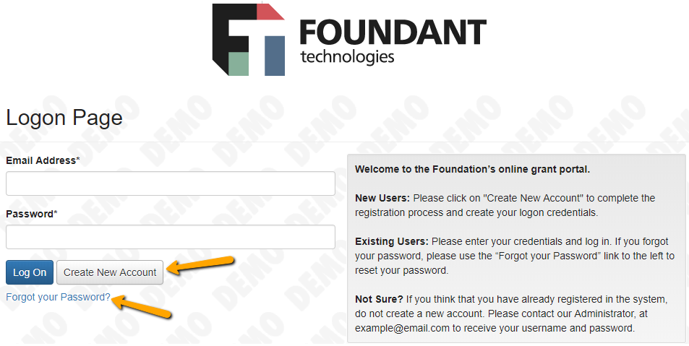

CREATE NEW ACCOUNT:
- Creating a new account is a multi-step process;
  - with the first section collecting Organization Information;
  - the second section collecting User Information;
  - and sections three and four collecting Executive Officer information.
- After Organization Information has been entered click on the “Next” button.
- The next section is the “User Information” section, or YOUR information.
  - If your address is the same as your organization’s you may use the “Copy Address from Organization” button to automatically pull the address information from the organization address fields into the address fields in this section.
  - It is very important to note that the email address entered in the Email/Username field becomes the Applicant’s Username in the system.
- Once the fields on the “User Information” section are completed, click on the “Next” button.
  - Please note that should you need to navigate to previous section in the registration process, you must use the “Previous” button at the bottom of each section in order for the information entered in registration fields to remain intact. If you attempt to navigate to the previous section by using their browser's “back” button you will lose all registration information entered.
- In the next section you indicate if you are the Organization’s Executive Officer.
  - If you are the executive officer, select “Yes.” You are taken to a section of optional fields that includes only the fields that were not required in the “User Information” section.
  - If you are not the executive officer, select “No,” and complete the required Executive Officer fields.
- Once the executive officer’s information is entered, click on the ”Next” button to create a password.
- Password requirements are listed at the top of the section, so the applicant can create their password accordingly.
- Once the password is created, the applicant clicks the “Create Account” button.
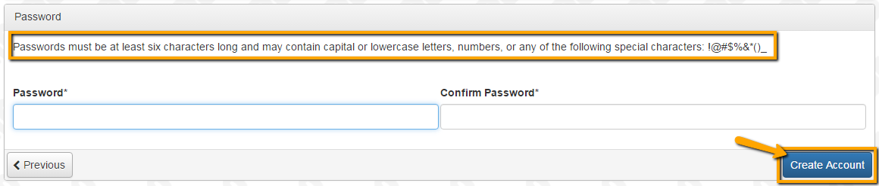
EMAIL CONFIRMATION:
Upon clicking Create Account you will be taken to the Email Confirmation page, so you can confirm that you are receiving emails from the system. Follow the onscreen instructions and click the “Continue” button to finish the registration process. Now you have an account in this system, and remember, this is an account that you will use for both present and future applications.

VIDEO 2: Applying for Funding

Upon completing registration and accessing the system for the first time, you will land on the Apply Page. This page will show you any currently open opportunities that you can apply for, as well as any relevant deadlines and other applicable information related to them.
- If you’ve been provided an access code, you may enter it in the upper right-hand corner to reveal the opportunity you have been invited to apply to.
- You can preview the application without having to save any work by clicking on the “Preview” button.
- To start a request, click on the blue “Apply” button under the opportunity you’d like to apply to.
  - Clicking Apply will take you into a form to complete and submit. Depending on the Foundation the form will likely be an LOI or Application. In this example, you are taken directly into the application.
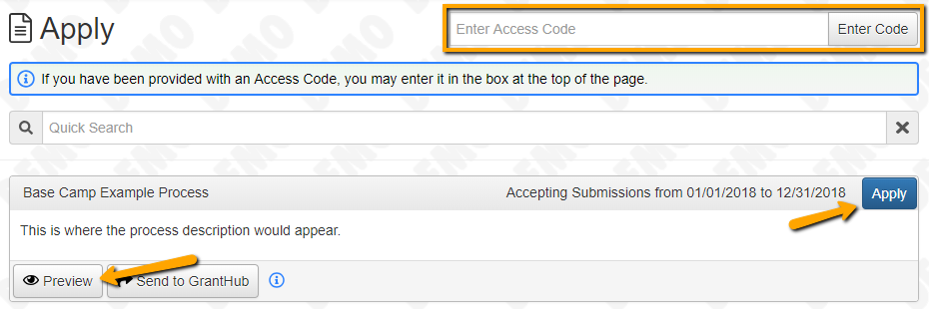
Once in the form, note that your contact and organization information automatically populates at the top of the form.
- You may update your contact information and view your email history.
  - If the Foundation allows applicants to update organization information you will see the edit icon next to the Organization Information.
  - If not, you must contact the Foundation directly to change organization information.
- If you’d like a PDF copy of the application, you can click the Question List button.
- Once you’ve completed the form, you may click the Application Packet button to download a copy of the questions and your responses.
- (NEW starting 6/12/18) Please note that if the form has a specific deadline it will be listed at the top of the form.
  - Depending on the Foundation you may or may not be able to submit after the deadline has passed.
    - If the past due message is reflected in orange, you may still submit the form.
    - If the past due message is reflected in red, you no longer have the option to submit the form.
      - If you are not allowed to submit, you will receive a message should you attempt to submit.

Work your way through the form responding to the fields.
- Note that any fields with an asterisk are required fields and must be completed prior to submitting an application.
- As you complete the form, the system will auto-save every 100 characters typed or every time you click out of a field.
- You may collapse question groups as you go, once you’ve finished all of the questions in that group, as an indicator to yourself that you’ve completed that section and reduce scrolling.
- Some fields have character limits.
  - Responses that are longer than the set limit will be saved, but an error message will appear informing the applicant the the limit has been exceeded.
    - You will not be allowed to submit the form until the length of the response has been decreased in accordance with the limit.
- File upload fields will only accept one file, per field.
  - Upload fields have size limits.
    - If you attempt to upload a file that is larger than the set MiB limit, you will receive an error message informing the applicant that the file is too large and the file will not be saved.
  - Upload fields may also have File Type restrictions.
    - If you attempt to upload a file type in an unaccepted file type acceptable file type you will receive a warning that the file type is not acceptable and you will not be able to upload the file.
  - Once a file has been uploaded, it may be deleted by clicking the red X next to the file name and a new file can be uploaded.
- Even though the system is auto-saving there is still a “Save” button at the bottom of the form.
  - When you click save you are taken to a confirmation page so you know the save was successful.
    - If you click “Continue” you will be taken back into the form so you can continue working.
    - If you save and exit the system, you will access the draft of the form from your Dashboard the next time you log in.
      - Pick back up where you left off by clicking “Edit” link to the right of the request.

- You may abandon the request if it is the first form to be submitted for this request.
  - Once the first form, either an LOI or Application, has been submitted you must contact an administrator to withdraw the request from consideration.
  - After selecting Abandon Requests, you must type in Abandon Request and select OK
  - The request will then be visible in the Historical Requests tab just as it would if an administrator had abandoned the request.

When all of the fields are complete, submit the application.
- If any required fields were not completed, or a response to a text question type is longer than the set limit, the system will not allow the form to be submitted.
  - An error message appears listing the fields that need to be completed or edited.
  - These fields are outlined in red so they are easy to identify as the applicant scrolls through the form.
- When a form is submitted successfully, the applicant will be taken to a confirmation page.
  - When the you click “Continue” you are taken to your dashboard where you can VIEW your submitted request.
  - Note, that once an application has been submitted you can no longer edit it.

VIDEO 3: Your Applicant Dashboard
Your dashboard houses current and historical requests.

(NEW starting 6/12/18) The active request tab houses all current requests. These are the requests still requiring action, awaiting a decision and/or requests that have not yet been marked closed by the site administrator. Within each request you can see forms, form statuses and submission dates and, if applicable, form deadlines.

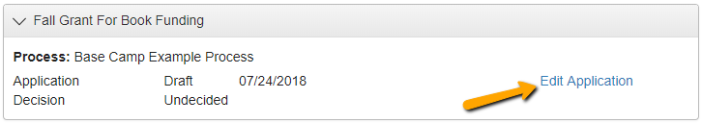
- You may continue working on saved forms by clicking the edit option next to the form.
- You may view forms that have been submitted but note that once submitted you can not edit them.
- You can also see the request’s decision status.
  - The status will be “Undecided” until the site administrator posts a decision.
    - Timing on decision status updates vary depending on the foundation.
If your request is approved you may be assigned Follow Up Reports to be completed and submitted through the system.
- Follow ups are completed and submitted just like any other form.
- If you’ve been assigned multiple follow up forms, you must complete them sequentially by due date.
- Follow ups that are past due will be marked as such.
  - If the past due message is reflected in orange, you may still submit the form.
  - If the past due message is reflected in red, you no longer have the option to submit the form.

(NEW starting 6/12/18) Denied requests and requests marked closed by the site administrator are housed in the Historical Request tab.

If you wish to edit your account information or change your password, click your name in the top right. This will expand a drop-down menu. If you click Edit my profile, you will be able to update your user information or change your password. Be sure to click save in the bottom right once you’ve finished.

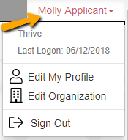

Please note, that you will be automatically logged out of the system after 90 minutes of inactivity (you
will receive a warning message at 80 minutes of the pending “time out”).

